Java
Q1 | create a java program which had the concept of class and object class student, data members (roll and name). consider by default static value variable name as total. find out the percentage and display student roll no, name, and percentage.
Code | import java.util.*;  class student  {  String name;  int roll;  int total;  float percentage;  void input()  {  Scanner sc = new Scanner(System.in);  System.out.print("Enter name: ");  name = sc.nextLine();  System.out.print("Enter Rollno: ");  roll = sc.nextInt();  total = 450;  percentage = total/5;  }  void display()  {  System.out.println("");  System.out.println("Name: "+name);  System.out.println("Roll: "+roll);  System.out.println("Percentage: "+percentage);  }  }  class tmp  {  public static void main(String args[])  {  student s1 = new student();  s1.input();  s1.display();  }  }
Output | 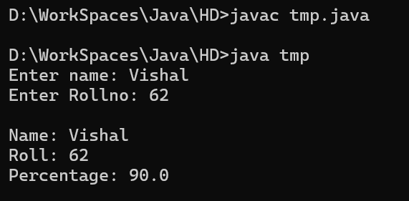
Q2 | Create a java program using the concept of class , object and scanner. the data members are inside the class emp - employee id, name, salary, total number of leaves. calculate gross salary (s+hra+da+pf). hra= 20% salary, da= 10% salary, pf = 200 rupees. if leave is less than 2 give the official salary id leave is greater than 5 deduct 5% salary, if leave is more than 8 deduct 30% from the salary.
Code | import java.util.*;  class employee  {  String name;  int id;  int leaves;  double salary;  double hra; //30%  double da; //10%  double s_gross;  void input()  {  Scanner sc = new Scanner(System.in);  System.out.print("Enter name: ");  name = sc.nextLine();  System.out.print("Enter id: ");  id = sc.nextInt();  System.out.print("Enter number of leaves: ");  leaves = sc.nextInt();  System.out.print("Enter salary: ");  salary = sc.nextDouble();  hra = (salary * 0.3);  da = (salary * 0.1);  s_gross = ((salary + hra + da)- 200);  }  void display()  {  System.out.println("");  System.out.println("Employee ID: "+id);  System.out.println("Name: "+name);  System.out.println("Leaves: "+leaves);  if(leaves >= 5 && leaves < 8)  {  s_gross = s_gross - (s_gross * 0.05);  System.out.println("Gross Salary: "+ s_gross);  }else if(leaves >= 8){  s_gross = s_gross - (s_gross * 0.05);  System.out.println("Gross Salary: "+ s_gross);  }else{  System.out.println("Gross Salary: "+ s_gross);  }  }  }  class emp_salary  {  public static void main(String args[])  {  employee e1 = new employee();  e1.input();  e1.display();  }  }
Output | 